Columbia Foundation School
D – Block, Vikas Puri, New Delhi - 110018

SYLLABUS : (2019-20)

Class – VII
Features & Guidelines

Complexity / Difficulty Level
Level | Description | Notes
1 | High (H) | Topic needs more attention
2 | Medium (M) | Needs moderate attention
3 | Easy (L) | Simple topic

- High Level of Difficulty implies more practice and parental guidance towards the topic.
- Classes for subjects like computer, Moral Science, General Knowledge, Drawing and Music are conducted once a week. Hence, the schedule is planned accordingly.
- In English, we have categorized the skills such as Reading, Writing, Vocabulary, Grammar, Speaking, and listening so that the child has a holistic approach towards the language.
- All the activities are relevant to the topic and are planned based on its difficulty level.
- Group activities will instill qualities such as teamwork, sharing and respecting others’ opinion among the students.
- Most of the activities help to bridge the gap between theory and practical connecting the students to real life processes.
- Constant recapitulation of the topics helps in proper comprehension and retention of the concepts.
- All the activities in mathematics are designed to erase off fear from the minds of the learners towards the subject.
- Please refer to the syllabus before contacting us for any queries related to the syllabus.

ENGLISH
UT | Month | Reader | Grammar | Supplementary | Activity
I | Apr. | Unit-1: Caring for Others  Sec. 1: Every Child free to be a Child  Sec.2: A Christmas Carol  Sec.3: The Bridge Builder | Ch-1: Sentence  Ch-2: Nouns  Ch-3: Adjectives  Ch-31: Paragraph Writing | Ch-1,2 | Watch the Nobel prize speech of Kailash Satyarthi and Malala Yousafzai & discuss in groups in class. Write your views, what will you, do facing a situation like this.
 | May | Unit-2: The World Around Us  Sec. 1: A True Story About Ladybugs | Ch-4: Articles  Ch-5: Pronouns  Ch-6: Verbs (Transitive & Intransitive)  Ch-7: Verbs (Present Tense) | Ch - 3 | -
II | July | Sec.2: Adolf  Sec.3: Written in the fields  Unit3: Importance of Science  Sec.1: For a while Misunder- stood him. | Ch-8: Verbs (Past Tense)  Ch-9: Verbs (Future Tense)  Ch-25: Synonyms & Antonyms | Ch - 4 | Find out the writers in English Literature who wrote keeping science as their theme. Mention their works.
 | Aug. | Sec2 : India’s Spacewomen  Sec3 : Retired – Jain Crichton - Smith | Ch-34: Story Writing  Ch-19: Sentences: Simple Compound, Complex  Ch-23: Words often Confused (1-10) | Ch – 5, 6, 7 | Women have achieved a lot of fame. Find out Indian women who have setup records for doing something unique.
H.Y.  Exam | Sept. | Unit 4: Birds & Animals  Sec.-1: The Boy and the Swallow | Ch-20: Transformation of Sentences | - | -
III | Oct. | Sec.2: A Tiger Comes to Town  Sec.3: Milk for the Cat | Ch-13: Adverbs  Ch-15: Conjunctions  Ch-29: Informal Letters | Ch - 8, 9 | Find out and paste the picture of birds and animals which are on the verge of extinction.
 | Nov. | Unit 5: Games & Sports  Sec.1: Lady of the Ring  Sec.2: Easily Distracted | Ch-33:Biographical Sketches  Ch-14: Prepositions  Ch-24: Words Followed by appropriate prepositions | Ch - 10, 11 | Find out & write about the sports which have got added in the Olympics.
IV | Dec. | Sec-3: Sports Day  Unit-6: How Mysterious  Sec.1: Uncovering the Ghost of Nancy Drew | Ch-10: Modals  Ch-23: Words of Often Confused  Ch-35: Writing Essays | Ch -12, 13 | –
 | Jan. | Sec.2: The Adventure of the Three Students  Sec.3: Miracles | Ch-12: Active Passive Voice  Ch-25: Synonyms & Antonyms (1-20)  Ch-29: Formal Letters | Ch – 14 | Elocution (Presentation in the class).
F.Y. Exam. | Feb | Revision | Ch-22: Integrated Grammar Practices (Revision of Whole Syllabus) | Ch-15, 16

MATHS
UT | Month | Reader | Activity
I | Apr.  -  May | Ch-1: Integers  Drill Ex. Pg. 1 to 9  Ch-3: Data Handling  Drill Ex. Pg. 26 to 33 | - Multiplication of fractions.
II | July  -  Aug. | Ch-2: Fractions & Decimals  Drill Ex. Pg. 10 to 25  Ch-5: Lines & Angles  Drill Ex. Pg. 40 to 48  Ch-13: Exponent & Powers  Drill Ex. Pg. 109 to 116  Ch-9: Rational Numbers  Drill Ex. Pg. 77 to 84 | - Vertically opposite angles.  - Angle sum property of a triangle.
H.Y. | Sept. | Ch-12: Algebraic Expressions  Drill Ex. Pg. 99 to 108 | - Exterior & Interior angles of triangle (Inequality relation).
III | Oct.  -  Nov. | Ch-6: The Triangle & its Properties  Drill Ex. Pg. 49 to 56  Ch-8: Comparing Quantities  Drill Ex. Pg. 65 to 76 | - Exterior & Interior angles of triangle (Equality relation).
IV | Dec.  -  Jan. | Ch-7: Congruence of Triangles  Drill Ex. Pg. 57 to 64  Ch-11: Perimeter & Area  Drill Ex. Pg. 89 to 98  Ch-4: Simple Equation  Drill Ex. Pg. 34 to 39 | - Measure the dimensions of your text book & notebook & find its area & perimeter. .
F.Y. EXAM | Feb | Ch-10: Practical Geometry  Drill Ex. Pg. 85 to 88  Revision | -

SCIENCE
UT | Month | Topic | Activity
I | Apr. | L-1: Nutrition in Plants  L-2: Nutrition in Animals | - To show that chlorophyll is necessary for photosynthesis (Activity 1 as per pg. no. 7)
 | May | L-14: Heat and Temperature  L-15: Transfer of Heat | - To observe expansion in gases.  (Activity 3 as per pg. no. 153)
II | July | L-5: Acids, Bases & Salts  L-7: Soil  L-8: Respiration in Plants & Animals | -
 | Aug. | L-12: Electricity and Magnetism  L-10: Reproduction in Plants | - To make an electromagnet  (Activity 6 as per pg. no. 132)
H.Y. | Sep. | L-4: Chemical reactions | -
III | Oct. | L-3: Fiber to Fabric  L-9: Transportation of Materials  L-16: Water | - To show transpiration  - (Activity -3 as per pg. no.87).
 | Nov. | L-17: Forests  L-13: Light and Reflection | - Make a Newton’s disc by using circular disc with seven colours.
IV | Dec. | L-11: Time and Motion  L-7: Weather,Climate and Adaptations  L-19: Winds & Storms | - To observe uniform & non-uniform  motion (Activity 5 & 6 as per pg. no. 121)
 | Jan. | L-18: Waste water Management | -
 | Feb. | Revision & Final Year Exam.

SOCIAL SCIENCE

UT | Month | Topic | Activity
I | Apr. | H-1: Tracing changes through a thousand years  G-1: Environment  C-1: Equality in Democracy | Map Skill: Mark states and capitals of India in the political map of India.
II | May | H-2: New Kings & Kingdoms  G-2: Inside our Earth | -
 | July | C-2: The State Government  H-3: The Delhi Sultanate  G-10: Life in the desert | -
 | Aug. | H-4: The Mughal Empire  G-3: Gender  C-3: Our Changing Earth | Map Work: Mark different areas occupied by ruler during Mughal period.
H.Y.  EXAM | Sept. | G-5: Air H-7:Tribes,Nomads and Settled Communities | -
III | Oct. | H-8: Devotional Paths to the Divine  C-4: Understanding Media & Advertising  G-5: Water | Prepare a social advertisement in group on any cause.
 | Nov. | H-9: The Making of Religion Cultures  G-9: Life in the Temperate Grasslands  G-6: Natural Vegetation & Wildlife | Map Skill: Mark different forests found in different parts of the world.
IV | Dec. | H-10 : 18th Century Political Formations  C-5: Markets  G-7: Human Environment Settlement, Transport & Communication | Map Work: Mark different states formed in the 18th Century on the political map of India.
 | Jan | G-8: Human Environment Interactions – The Tropical and the Sub -Tropical Region. | -
F.Y.  EXAM | Feb | H-5 Rulers & Buildings | Revision

* Note: 1. G- Geography 2. H- History 3. C- Civics

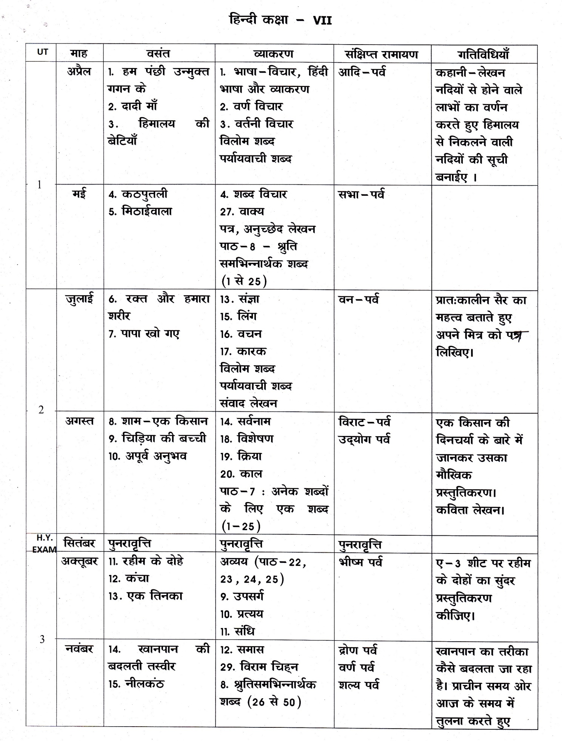

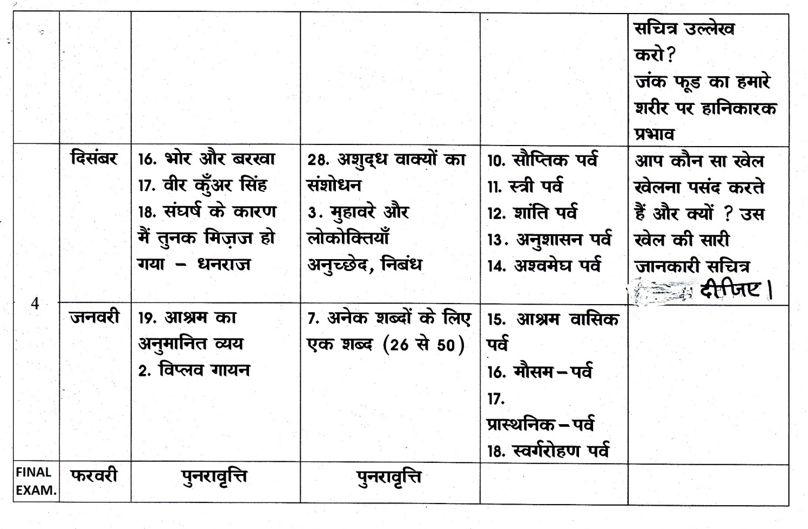

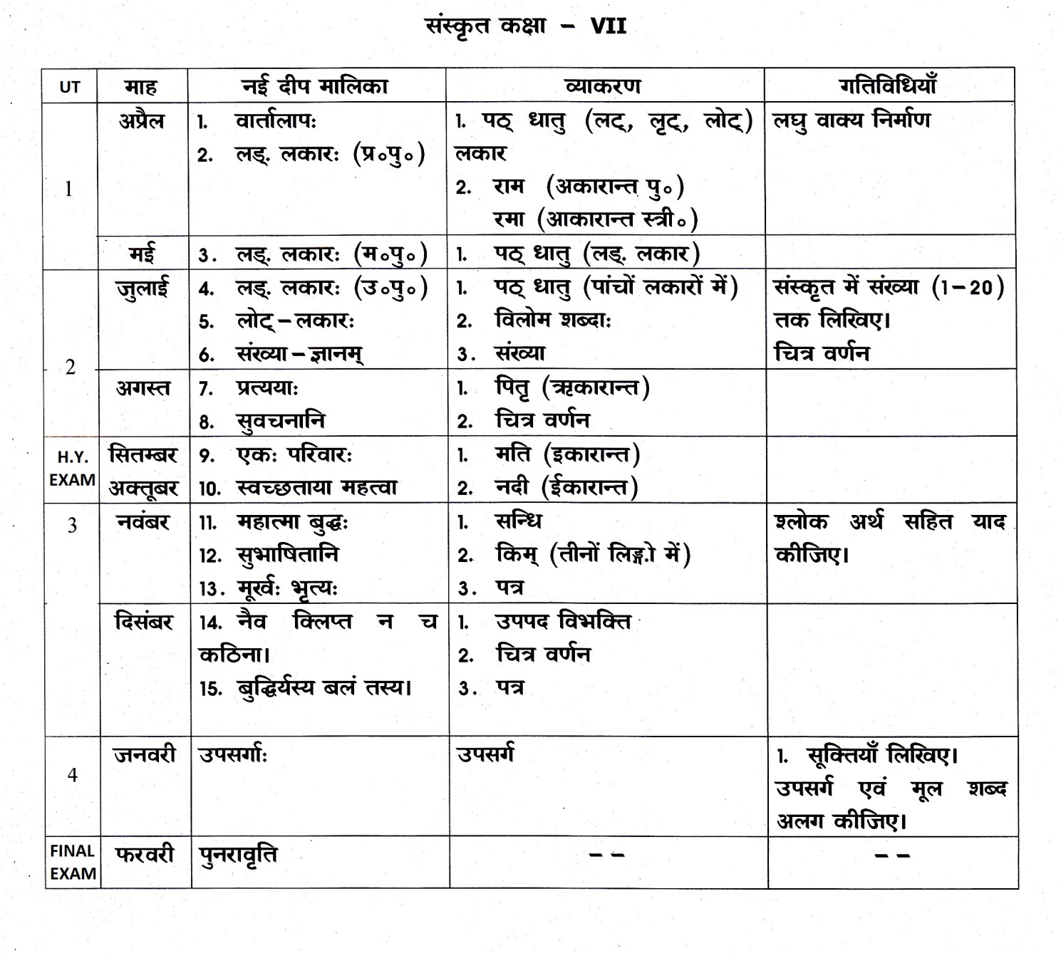

GENERAL KNOWLEDGE

UT | Month | Topic | Activity
I | Apr. | The Natural World  - Lighten up – You live only once  - Geo animals adapt  - Geo wonders  - Forest quest  - How plants adapt  - Threats to wildlife  - Antarctic adventures  - Kingdom of the ocean | - Paste pictures of any five extinct and endangered species and write a few lines on them.
 | May | Science & Technology  - Indian scientists  - Inventions  - On the move  - Science Quiz | -
II | July | Science & Technology  - Branches of science  - Space quiz  - The chemistry of it  - II Queries  - Unique universe  - 20th Century inventions | - Label and draw any five constellations on a black sheet and paste it in your notebook.
 | Aug. | Things Around Me  - Environmental treats  - Tackling garbage  - Eco Crossword  - Making recycled paper  - Deadly disasters  - Conserving water | Prepare poster on any one from the following topics:  - Conservation on of water  - Segregation of waste
H.Y.  EXAM | Sept. | Numbers & Logical Skill  - Brain teasers  - Maths magic  - Prickly magic | –
III | Oct. | Language & Literature, Legends  - Mythical creatures  - Story time  - Book land  - Language word search  - Guess the words  - Answering history | - Narrate any one moral story in the class.
 | Nov. | Sports  - Counting on courage  - Playing Hockey  - Cricket Twenty 20  - Martial Arts  - Game for Pool  - Sports Stars | - Paste the picture of your favourite sports person and list his/her achievements.

 | Dec. | The World Around Us  - Most popular cities of the world  - Tradition tour  - Famous people  - Castles & places  - Ships ahoy  - Famous explores  - Tribes of India  - Around the world  - The United Nation  - Parliaments of the world  - Man-made wonders of the world  - Business giants  - Nobel woman  - Governing systems  - Lost cities  - Famous trains  - Talking 21st century  - Knowing eastern India  - Guess the brand | - Paste pictures of any five International festivals and write a few lines on them.
 | Jan. | Mixed Bag  - Quiz yourself 1  - Quiz yourself 2  - Quiz yourself 3  - Model test paper I & II | –
 | Feb. | Revision & Final Year Exam.

 |  | COMPUTER
 | Month |  | Topic | Activity
TERM 1 | Apr. |  | Ch-1: Computer languages & Number system | Perform conversion operations on various binary numbers
 | May |  | Ch-2: Knowing about operating system  R E V I | Paste pictures of different types of Operating system and their respective versions also  S I O N
 | July |  | Ch-3: Window movie maker  Ch-4: Excel 2016 functions | Create a movie of your birthday celebration or any other celebration  Create a list of expenditure in MS-Excel
 | Aug. |  | Ch-5: Advanced features of excel  R E V I | Evaluate the highest expenditure by using graphs  S I O N
 | Sep. |  | Ch-6 : Animation with adobe flash(CS6) | create an animation showing bouncing of a ball
TERM -2 | Oct. |  | Ch-7: Introduction to HTML | Design a small web page on your favourite sports person
 | Nov. |  | Ch-7: Introduction to HTML(Contd.)  Ch-8: Introduction to Photoshop (CS6)  R E V I | Change the colour of shirt of a boy , print it and paste in your notebook with 4 different colours  S I O N
 | Dec. |  | Ch-9: Cyber tools | Activity : Find about various types of security threats in major organizations
 | Jan. |  | Ch-10:Cyber crimes & security | Activity : Find about various types of viruses and worms and write about their side effects
 | Feb.  March |  | R E V I  F I N A L | S I O N  E X A M

ARTS & CRAFT

Term | Month | Art | Craft
Term – I | Apr. -  May | - Introduction of colours  - Elements of art  - Colour tone | - Waste material collage
 | July  -  Aug. | - Drawing tool  - Colour theory  - Still life | - Canvas painting  - Warli painting
 | Sep. | - Perspective view  - Step drawing | - C D craft.
T e r m - III | Oct.  -  Nov. | - Portrait  - Henna & tattoo art  - Awareness poster | - Canvas rangoli  - Glass painting.
 | Dec.  -  Jan. | - Human anatomy  - Geometrical composition  - Folk & tribal art | - Fabric painting.
 | Feb. | - Different styles of calligraphy.

